**Development of An Iot-Based Daylight Responsive Lighting Control & Monitoring System for Interior Environments**

**Introduction:**

In recent years, there has been a noticeable shift towards incorporating energy-saving technologies into various applications, particularly in response to increasing concerns about energy consumption and environmental sustainability. One significant area of focus is smart homes, which utilize advanced technologies like machine learning, artificial intelligence, and the Internet of Things (IoT) to optimize energy usage while enhancing living experiences. Lighting, being a substantial contributor to overall energy consumption, has garnered attention in smart home solutions for its potential to conserve energy and improve efficiency. The concept of smart house technology was first introduced by the American Association in 1984, marking the beginning of a journey towards more intelligent and sustainable living spaces.

**Methodology:**

To maintain the total lux of the light and reduce the overall consumption of the electricity uses of the day time we use automation for brightness intensity control of the light. Although here we use manually brightness intensity control system for benefit of when extremely low or high light required then it will be helpful. The overall block diagram describes the overall planning of automation and manual control of the brightness intensity of the light.

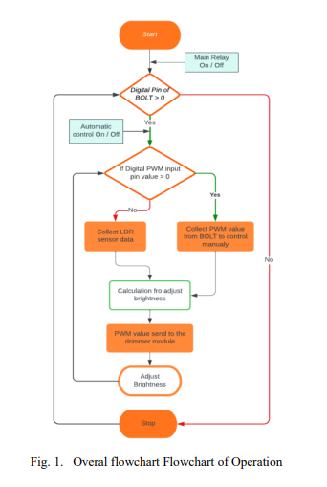

his system is based in the Pulse wide modulation (PWM) control. First in Automatic brightness intensity control it is necessary to turn on the main switch and automatic control switch button which is in the IoT platform On / Off button after that the Arduino collect the LDR sensor data and it will be processed and calculate then the PWM value send to the Arduino PWM digital I/O pins. Then the signal is transferred to the dimmer module, the dimmer module controls the incoming AC voltage, then the voltage will be control according to the percentage of the light in the environment. When if the manual control here uses bolt device for controlling the PWM signal. BOLT IoT module has an inbuilt PWM pin. The PWM value control by the BOLT own online IoT platform. For dragging the slight bar, the PWM value will be change accordingly. After then the PWM value is collect by the Arduino and process this data and send the PWM pulse to the Arduino Digital Input/Output pin. This data is transferred to the dimmer circuit and it will be controlling the Input AC voltage and the Light will be Dreaming according to the manual control of the BOLT IoT system. The connection diagram is shown in the Fig. No 2. Arduino Uno is the main controller which is control the PWM value and feed this to the dimmer module. The supply of the Arduino is feed through 5-volt DC. The dimmer module getting +ve and -ve from the Arduino 5-volt supply pin, and the Zero-Crossing (Z-C) and PWM pins are connected to the Arduino 3 and 12 Digital I/O pin. LDR is connected to the Arduino analog pin A0. Supply of the BOLT IoT module is feed from the 3 v DC source. And the PWM data (A0) pin of BOLT is connected of the Arduino Digital pin 6. The relay is connected to the BOLT 2 no Digital I/O pin and also one LDR pin is connected to the BOLT digital 4 no pin for collect the LDR data for showing the graph format.

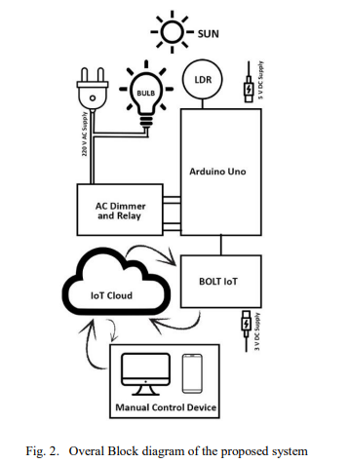

**Results:**

Preliminary results demonstrate the effectiveness of the proposed system in maintaining optimal light levels while minimizing energy consumption. Through real-time monitoring and control, users can observe and adjust lighting conditions remotely, contributing to improved energy efficiency and comfort in indoor environments. The system's ability to adapt to changing light conditions and user preferences highlights its potential for widespread adoption in smart home applications.

**Conclusion:**

In conclusion, the proposed IoT-based smart lighting control system offers a promising solution for enhancing energy efficiency and convenience in indoor environments. By leveraging advanced technologies and real-time monitoring capabilities, the system enables efficient management of artificial lighting while promoting sustainability and comfort. Future research could focus on further optimization of the system and its integration with emerging technologies to address evolving energy challenges and user needs.